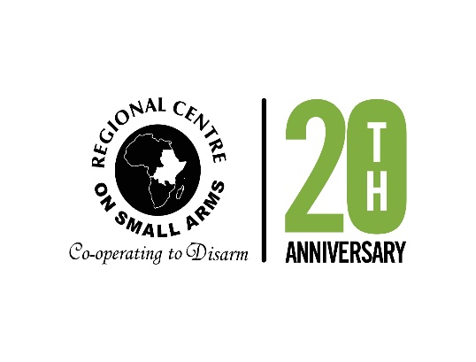

**STATEMENT**

**DELIVERED BY**

**MR. JEAN PIERRE BETINDJI**

**RECSA EXECUTIVE SECRETARY**

**AT THE**

**ELEVENTH CONFERENCE OF STATES PARTIES TO THE ARMS TRADE TREATY (ATT CSP11)**  
**GENEVA, SWITZERLAND**

**AUGUST 2025**

Mr. President,  
Distinguished Delegates,  
Ladies and Gentlemen,

It is a privilege to address this Eleventh Conference of States Parties to the Arms Trade Treaty. On behalf of RECSA, allow me to express our deep appreciation to the President of CSP11 and the ATT Secretariat for the continued prioritisation of universalisation especially in regions where the Treaty’s promise has yet to be fully realized.

This year marks a significant milestone for RECSA: two decades since the adoption of the Nairobi Protocol, under which we have worked with our 15 Member States across the Great Lakes Region, the Horn of Africa and Bordering States to coordinate the implementation of the Nairobi Protocol. As we commemorate 20 years of action, our experience has underscored a simple truth: arms control is not a theoretical aspiration. It is a practical necessity for peace, for human security and for sustainable development.

This is why RECSA has made universalization of the ATT in our region a strategic focus. In July this year, RECSA had the honour to co-host, in collaboration with Saferworld and SRIC, the Ninth ATT Expert Group Meeting in Mombasa, Kenya. This meeting brought together Member States, experts and civil society actors to build technical understanding of the Treaty, foster regional peer-to-peer learning and lay the foundation for tailored national roadmaps toward accession and implementation.

The outcome was clear: there is momentum. There is interest. There is political will provided it is matched by practical support.

RECSA stands ready to be a regional anchor for that support. As a recognised regional body with two decades of technical experience in legislative harmonization, stockpile management and electronic recordkeeping, we are uniquely placed to serve as a bridge between ATT frameworks and national systems. We are working closely with partners including the ATT Secretariat, the EU Outreach Programme implemented by Expertise France and civil society actors to build institutional capacity and mobilize resources through the Voluntary Trust Fund and other channels.

RECSA Secretariat views the ATT as complementary, not competing with the Nairobi Protocol. These two instruments can reinforce national control frameworks, contribute to the African Union’s Silencing the Guns initiative and support the realization of Sustainable Development Goal 16.

Mr. President,

We commend the leadership of CSP11 in spotlighting universalization. We echo the call to strengthen engagement with regional organizations, parliaments, and civil society. And we affirm that youth, survivors of violence and affected communities must be brought into this conversation not just as beneficiaries, but as partners in shaping a safer future.

As RECSA reflects on our past 20 years, we look ahead with renewed determination to support the next decade of ATT implementation. We will continue to advocate, convene and build capacity so that the Arms Trade Treaty becomes a regional reality.

I thank you for your kind attention